JH4. FRANK HURLEY REAL PHOTO SERIES [n.l.1926]

Ph Frank Hurley
F Title is in Roman caps. within single-line frame and superimposed on photo
in white.
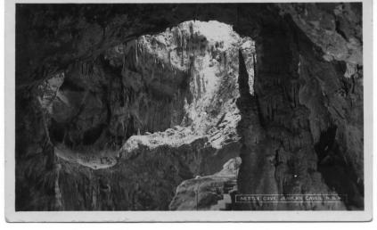
JH4.1 Nellie's Grotto, Right Imperial,/Jenolan, N.S.W. H (s.n.a. JH2.7) K-D
JH4.2 Grand Arch, Jenolan Caves, N.S.W. H K-B
Grand Arch, Jenolan Caves, N.S.W. H K-D
JH4.3 Grand Arch (Wet Day) Jenolan Caves, N.S.W. V K-B
JH4.4 Indian Chamber, Orient Cave, Jenolan, N.S.W. V [ms.13 Jul.1926]
JH4.5 Nettle Cave, Jenolan Caves, N.S.W. H K-D
JH4.6 Lucinda Cave, Left Imperial, Jenolan, N.S.W. H K-D
Lucinda Cave, Left Imperial, Jenolan, N.S.W. H K-B
Lucinda Cave, Left Imperial, Jenolan, N.S.W. H (pm. 4 Dec.1929) ?
JH4.7 The Canopy, Orient Cave, Jenolan, N.S.W. V K-D
The Canopy, Orient Cave, Jenolan, N.S.W. V K-B

